**Title:** Lab 9. Transistor Amplifier Part I

**Name:** Robert Bara **Partner:** Dalton Hamilton, Mohamad Asaf, Abdulaziz Almersi

**General Objective:** Lab 9 examines how transistors can a basis for amplifiers. This is examined by investigating the characteristics and behavior of a transistor amplifier with proper biasing to correctly polarize a transistor to amplify an AC voltage signal.

**Background Activities:**

Amplifiers aim to take a small input signal and increase the signal voltage to amplify the signal. The three standard Bipolar Junction Transistor (BJT) configurations that use one transistor are:

1. The **common collector** which is an emitter follower and typically used as a voltage buffer by using the base as an input, the emitter acts as an output, and collector becomes the common to both, making the circuit’s impedance provide a current gain instead of voltage gain. Combine this configuration with a Zener diode to create a voltage regulator.
2. The **common base** can be used to create a current buffer or voltage amplifier. The emitter is the input, whilst the collector is the output. Base is connected to the ground. This amplifier is popular within microphones, acting as a preamp because of its low input impedance. VHF and UHF range frequency amplifiers also use this configuration often to isolate the input and output, thus preventing feedback.
3. The **common emitter** amplifiers typically act as a voltage amplifier. The base is the input and collector as output, while the emitter commons both terminals by tying them to a group reference or power supply rail. This amplifier is typically found in radio frequency circuits and low-noise amplifiers.

**Procedure**

Begin by building the following common collector amplifier. Using a 0.1V peak sine wave at 100 Hz for the AC input signal, run a transient sweep of the input and output with the stop time being 0.02s. Calculate the simulated circuit gain that is $A_{v}=V_{output/}V_{source}$. Finally, run an AC sweep with a start frequency of 10 Hz, stop frequency of 5 kHz of decade sweep type, with number of points per decade being 5, to generate a bode plot with logarithmic vertical scale. Measure the gain at 100 Hz.

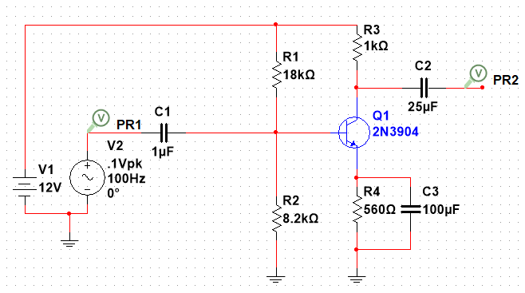

Figure . Common-Collector Amplifier

**Results:**

* 1. **Simulation Results**

Below is the circuit used for the simulation.



Figure . Common Collector Amplifier for simulation

Upon running the transient sweep, the transient response yields the graph below with the red line being the small input signal and green being the amplified output signal.

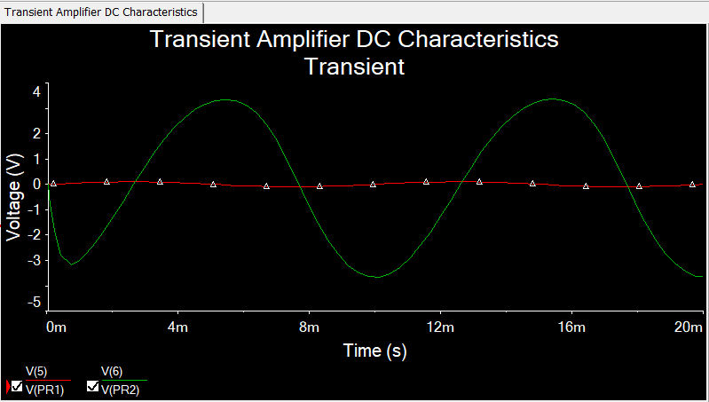

Figure . Transient Response of Amplifier

From the results of the transient response, the gain may calculated as $A_{v}=V_{output/}V_{source}$. I exported the values of the transient response into excel generating 4 columns, an X&Y column for Vin and X&Y column for Vout. Being that I wanted to find the ratio, I calculated the average of two positive cycles of the sinewave (neglecting negative values), and took the ratio as shown in the following chart. I also converted this value to decibels

|  |  |  |  |
| --- | --- | --- | --- |
| **AVG Vout** | **AVG Vin** | **Gain** | **Gain in dB** |
| 2.120349 | 0.054189 | 39.12851 | 31.84987 |

Running an AC sweep yields the following Bode plot, where red is the input and green is the output:

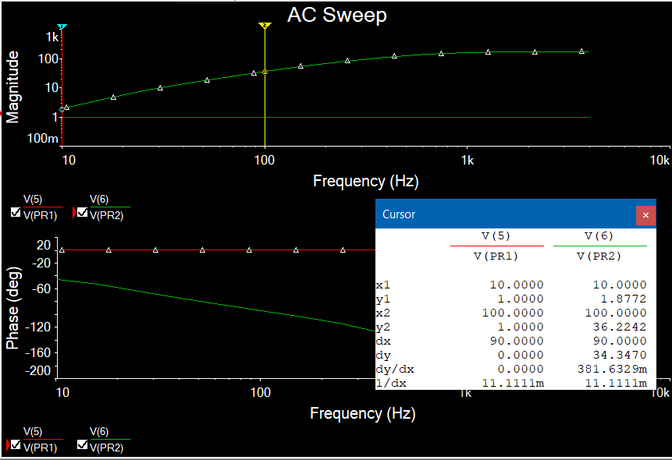

Figure . Bode Plot of Amplifier

Based on the Bode Plot, at 100 Hz, the amplifier holds a gain of 36.22 or 31.178dB, which is approximately a 3% difference in voltage gain, and less than 1% difference in decibel gain from my calculated value.

1. **Conclusion:**

The purpose of this lab was to introduce an example circuit of a common collector amplifier to become familiar with how the circuit uses a transistor and transistor biasing to amplify a small input signal. From running the transient response, I was able to successfully calculate the gain factor and compare it to Multism’s AC sweep’s gain value at 100 Hz. Understanding the transistor amplifiers, specifically the standard common collector, common base, and common emitter amplifier configurations are not only beneficial to the SPICE project, but also a building block of nearly any modern electric circuit that uses transistor amplification.